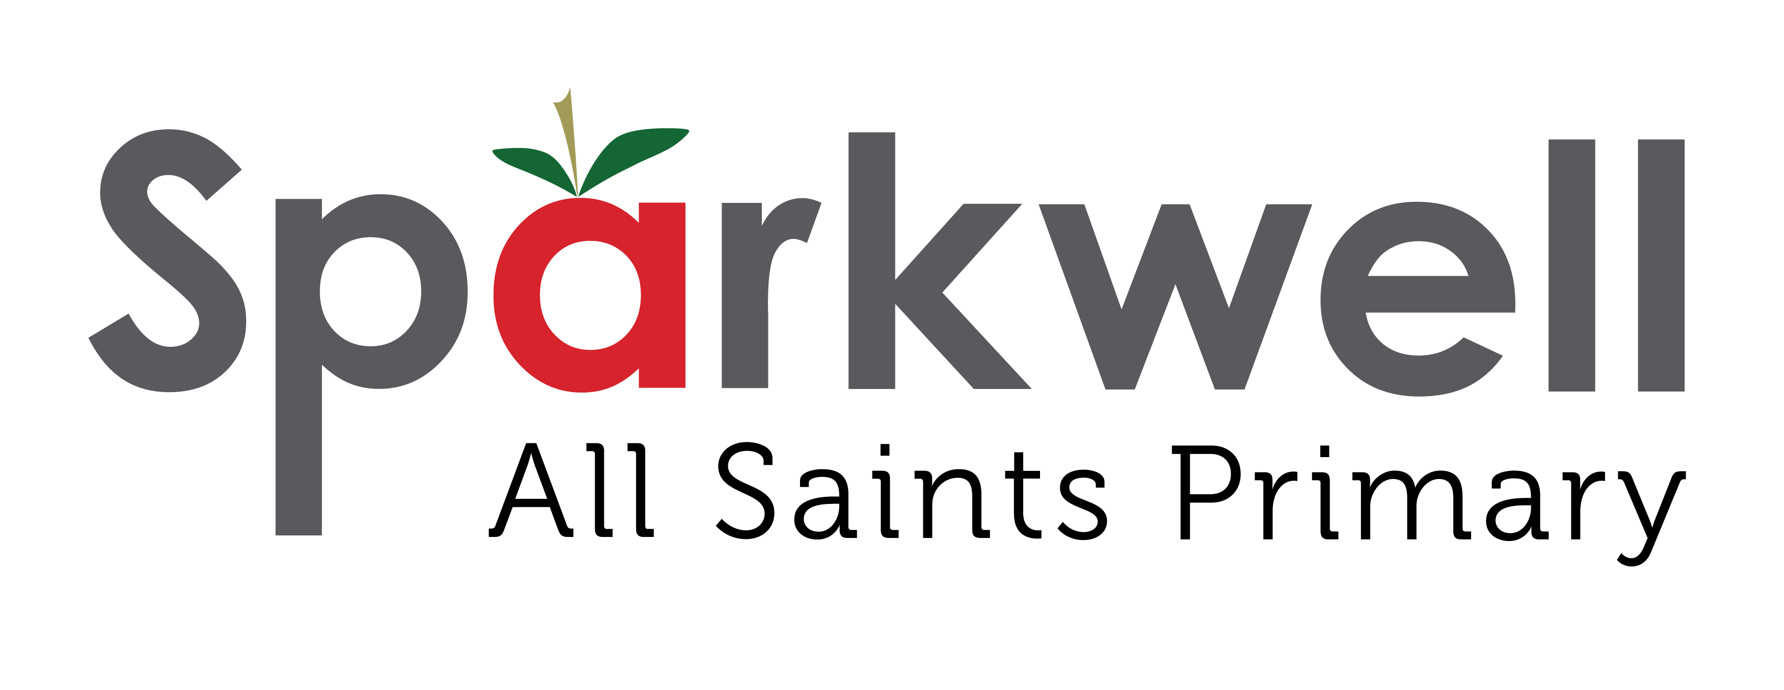
Collective Worship – Sparkwell Primary School 2023
The Link Academy Trust is a company limited by guarantee and an exempt charity, regulated by the Education & Skills Funding Agency (ESFA). All Members of the Board of Trustees of the exempt charity are also Directors of the company; the term 'Trustee' used in this Policy also means Director. This Policy applies to all staff within the Link Academy Trust.
Rational
Collective Worship plays a very important role in our academy. It is an opportunity to celebrate and nurture all aspects of school life, to support our values and our curriculum and to provide an opportunity for stillness and reflection in what is often a very busy, active day for our children.
Aims
The central aims of Collective Worship at Sparkwell Primary are to:
- provide our children with regular opportunities for stillness, reflection and response.
- highlight the core values which we uphold as an academy.
- promote children’s spiritual, moral, social and cultural development and support the fundamental British Values.
- celebrate the values and worth of the school community and all who belong in it, including the sharing of the gifts and talents of our children.
- provide opportunity to be inspirational and reflect upon the meaning and purpose of life, developing a sense of awe and wonder.
- help children develop and understand both the nature and language of worship in an inclusive and invitational manner.
- help children develop respect and sensitivity to the beliefs and values of others.
- support the broader curriculum through the use of art, music, dance, story, drama and other visual and oral means of communication.

The Legal Position
The 1988 Education Reform Act states that collective worship must be on a daily basis for all registered pupils. Furthermore, acts of worship “must be wholly or mainly of a broadly Christian character, i.e. reflect the broad traditions of Christian belief.”
At Sparkwell Primary we have developed a range of themes and topics through which collective worship takes place. Key themes include the British values of tolerance, democracy, liberty, respect, law and responsibility as well as joy, forgiveness and the value of all human life. We believe these themes/values are Christian in nature but are universal in their application. We recognise that in our academy we have children from a variety of faith backgrounds and that many children have no religious background at all. Great care is taken in our collective worship to ensure that all children feel valued and special and that their integrity as human beings is consistently upheld.
Collective Worship at Sparkwell Primary is an inclusive activity. Parents do have, of course, the right of withdrawal from Collective Worship. Parents who have any concerns about the provision and practice of our Collective Worship are strongly encouraged to contact the Academy Head.

Collective Worship and Assembly

An assembly is a gathering of part of all of our academy. Part of it can be concerned with administrative matters and other announcements about school life. It is of utmost importance that collective worship is seen to be distinct from those parts of the assembly that are concerned solely with administration. Collective worship is a context for allowing an individual to make a spiritual response freely if it is appropriate for them.

Context of Collective worship
In order to promote children’s learning, our acts of worship vary in size. Our pattern is set out below:
Monday - Whole academy (introduction of special theme as set out in a termly plan)
Tuesday - Class based assembly and time for discussion
Wednesday - Class-based worship on theme
Thursday - Year group development of theme
Friday - Whole academy (celebration / conclusion of theme involving pupils’ work)
Visitors play an important part in the life of our academy and regularly contribute to acts of worship. We carefully plan for and record our acts of worship to ensure a fresh and relevant programme which we can then evaluate for further development. We use a range of resources to enhance children’s learning. These include stories, music, poetry, art, drama, use of artefacts and online material, all of which we hope contribute to a stimulating and reflective time for our children.
We also believe collective worship makes a very important contribution to community cohesion in the following ways:
School Community- through our key themes/values and children’s participation in Collective worship we develop our school values of responsibility, resilience, respect and creativity.
Local Community- we encourage a range of regular visitors from our local community to enrich collective worship and support our children’s understanding of faith and beliefs
UK Community- we use powerpoints, short film clips, stories and other resources in our acts of worship to reflect the diversity of life and faiths in the UK.
Global Community- we use stories, music and online materials to enrich children’s understanding of faiths and cultures around the world and, at times, focus on giving to specific causes.
This policy must be reviewed and approved by S&C Committee on a 3-year cycle.
Reviewed by the Board of Trustees: 7 December 2020
Reviewed and approved by S&C Committee: 5th December 2023
Next Review: Autumn 2026

